- Get the List of Open weight LLM from different service providers
Open AI
OpenAI currently has two main open-weight LLMs, under the gpt-oss family:
Model | Total parameters | Active parameters | Approx. checkpoint | Best suited for
gpt-oss-120b | 116.8B | 5.1B | 60.8 GiB | Highest capability, complex reasoning, agents
gpt-oss-20b | 20.9B | 3.6B | 12.8 GiB | Local deployment, lower compute, faster inference
1. gpt-oss-120b
- OpenAI's most capable open-weight model.
- Mixture-of-Experts (MoE) architecture.
- Only ~5.1B parameters are active per token despite ~116.8B total parameters.
- Designed to fit on a single 80 GB GPU, such as an NVIDIA H100.
- Good for complex reasoning, coding, tool use, and agentic applications.
2. gpt-oss-20b
- Smaller and more resource-efficient version.
- ~20.9B total parameters, with ~3.6B active per token.
- Quantized checkpoint is about 12.8 GiB and can run on systems with as little as 16 GB memory.
- Better choice for local development and constrained hardware.
Also available: gpt-oss-safeguard
OpenAI also lists two open-weight safety-reasoning models:
- gpt-oss-safeguard-120b
- gpt-oss-safeguard-20b
These are specialized for safety classification, policy enforcement, content labeling, and trust & safety—not general-purpose chat applications.
Important distinction
These are open-weight, rather than fully open-source in every aspect. The weights are released under the Apache 2.0 license with the gpt-oss usage policy, allowing broad use, modification, and redistribution.

Qwen
1. Core Qwen Language Models
These are the general-purpose foundation and instruction-tuned models, designed to handle a wide variety of reasoning, chat, and text-generation tasks.
- Qwen2.5 Series (Released late 2024)
The foundational open-weight release that set a new standard for the family. It includes 7 dense model sizes: 0.5B, 1.5B, 3B, 7B, 14B, 32B, and 72B
. Most of these models support a context length of up to 128K tokens
- Qwen3 Series (Released 2025)
An architectural overhaul introducing advanced reasoning and Mixture-of-Experts (MoE) capabilities. Notable open-weight sizes include 4B, 30B-A3B, and 235B-A22B
. This generation also introduced "Thinking" variants (e.g., Qwen3-235B-A22B-Thinking), which are optimized for complex, step-by-step chain-of-thought reasoning
- Qwen3.5 / Qwen3.8 Series (Released 2026)
The latest iterations designed as native multimodal agents. This includes highly efficient variants like Qwen3.5-9B
, Qwen3.8-27B , and Qwen3.8-Flash-Next (180B)
. Some open-weight releases in this lineage even scale up to massive 2.4 trillion parameter sparse architectures
2. Specialized Open-Weight Models
Qwen also releases domain-specific models that share the same core architecture but are fine-tuned or continuously pre-trained on specialized datasets.
- Qwen-Coder (e.g., Qwen2.5-Coder, Qwen3-Coder)
Optimized specifically for software development, code comprehension, and agentic coding workflows. Available in sizes such as 0.5B, 1.5B, 3B, 7B, 14B, and 32B
. Qwen3-Coder is explicitly designed for local development and terminal-based AI agents .
- Qwen-Math (e.g., Qwen2.5-Math, Qwen3-Math)
Tailored for advanced mathematical reasoning, proof generation, and step-by-step problem-solving. Released in sizes like 1.5B, 7B, and 72B
- Qwen-VL (Vision-Language)
Multimodal models capable of high-quality image, video, and document understanding. The Qwen2.5-VL series scales up to 72B parameters while newer iterations like Qwen3-VL are available in highly efficient sizes like 8B/9B for local multimodal tasks
- Qwen-Audio
Specialized models for automatic speech recognition (ASR) and audio processing tasks, available in lightweight sizes like 0.8B and 2B
- QwQ
An early, dedicated reasoning-focused model series (e.g., QwQ-32B) that pioneered the open-weight "thinking" or deep-reasoning approach for the Qwen family before it was integrated into the main Qwen3 line
3. Licensing and Commercial Use
One of Qwen’s biggest advantages is its permissive licensing:
- Apache 2.0 License: The majority of Qwen’s open-weight models (especially the 0.5B through 32B sizes, and many 72B variants) are released under the Apache 2.0 license
- This makes them highly attractive for commercial, self-hosted, and enterprise deployment without restrictive geographic or user-cap limits .
- Qwen Research License: A few of the largest or most specialized experimental models may use this license, which is still highly permissive but may require explicit permission for very large-scale commercial deployments .

Deepseek
- Overview: Developed in China, DeepSeek models are highly regarded for their advanced reasoning, coding capabilities, and highly cost-effective inference architecture (e.g., MoE)
- Notable Models: DeepSeek V3, DeepSeek R1 (reasoning-focused), and subsequent V4 iterations (Flash and Pro)
- License: MIT License (highly permissive).
DeepSeek has released several open-weight models. Many of their flagship models are released under a permissive MIT license, allowing for broad commercial use

Flagship Reasoning & General-Purpose Models
DeepSeek-R1 (671B parameters): A flagship reasoning model, released under the MIT License, which performs on par with OpenAI's o1 on reasoning tasks. It is designed for complex problem-solving
DeepSeek-V3 / V3.2 (685B parameters, MoE): General-purpose models with Mixture-of-Experts (MoE) architectures for high efficiency. V3.2 is the latest version and includes DeepSeek Sparse Attention for improved long-context performance
DeepSeek-V3.1-Terminus: An upgrade of V3.1 focused on enhancing coding, search, and agentic tasks with more consistent language output. Also released under the MIT License
Specialized & Smaller Models
DeepSeek-R1 Distilled Models (1.5B to 70B): Smaller, more efficient models distilled from the larger R1, making them suitable for different computational budgets. They are based on the Qwen and Llama architectures
DeepSeek-Coder / V2: Specialized models for code generation and software engineering tasks
DeepSeekMath (7B) / DeepSeekMath-V2: Models focused on advanced mathematical reasoning and formal theorem proving
DeepSeek-VL / VL2: Vision-language models for multimodal understanding and generation tasks
Janus: A unified multimodal model designed for both understanding and generation
DeepSeek LLM (7B/67B): Earlier foundation models that provide a basis for scaling law studies

2)Hallucination check for the below prompt
Write a 4-line poem where every line ends with a word that
strictly rhymes with the word ‘Silver’
Deepseek:
A flash of light upon the river,
The moon’s cold gleam, a silent shiver—
No treasure found, no hands that quiver,
Just ghostly boats that drift and sliver.
Gemini Ai:
No word in the English language provides a strict, perfect rhyme for silver.
Standard rhyme dictionaries and literary consensus consider "silver" an unrhymable word alongside terms like "orange," "purple," and "month." Half-rhymes or slant rhymes exist—such as quiver, river, sliver, or deliver—but these share only the vowel sound rather than a strict, perfect phonetic match.
Chat GPT:
There is no standard English word that strictly (perfectly) rhymes with “silver.”
If repeating the same word counts, here’s a technically strict version:
Moonlight shimmers softly on the silver
Dreams drift quietly beside the silver
Stars awaken, glowing like the silver
Night holds every secret in the silver
Qwen:
The freezing wind makes mortals shiver,
And makes the heavy bowstring quiver,
A bright and cold metallic sliver
Of moonlight that the clouds deliver.

3) From open router take the model details with Context window for any 10 models from 3 service providers
https://openrouter.ai/models
Open AI:
OpenAI GPT Astra Latest :
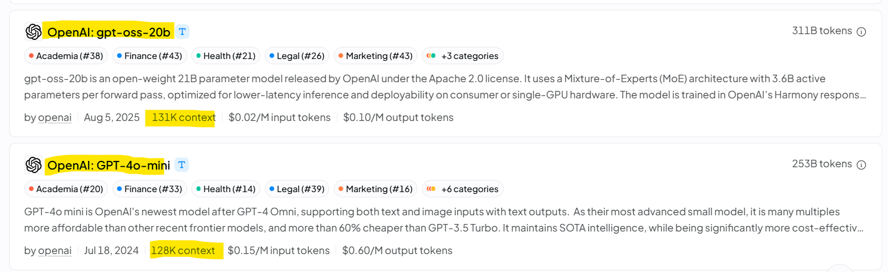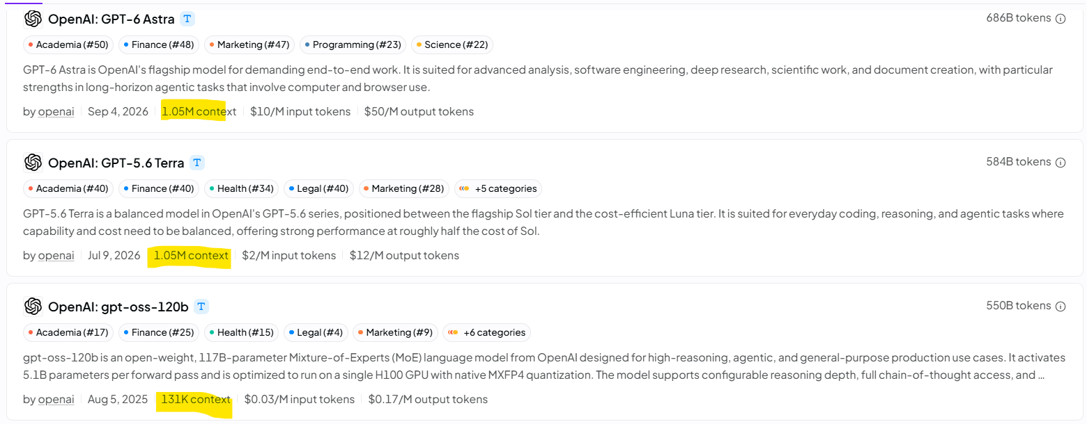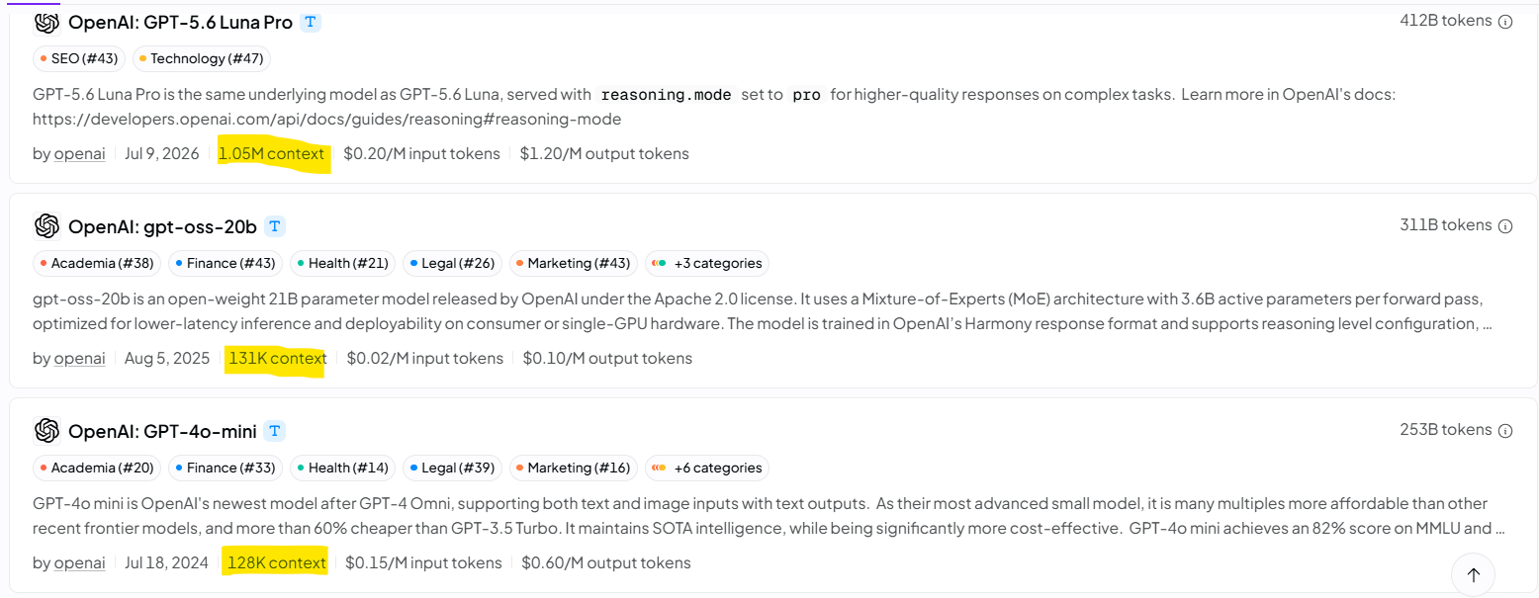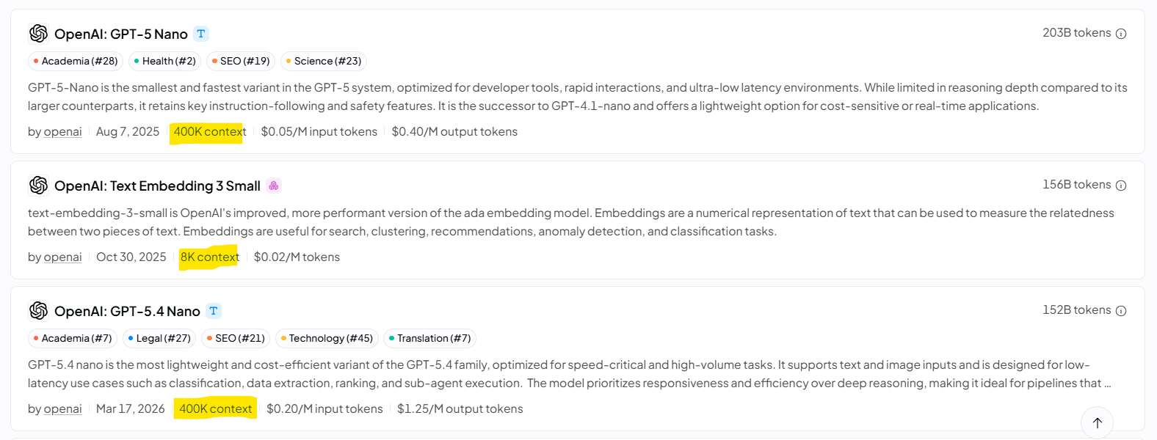

DeepSeek:
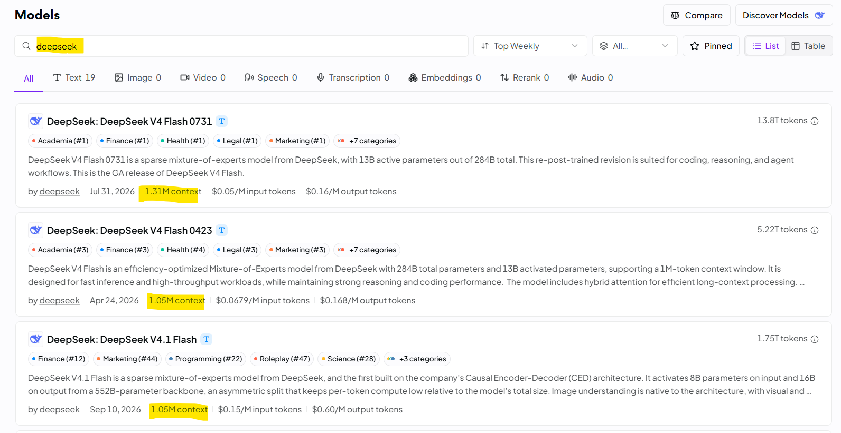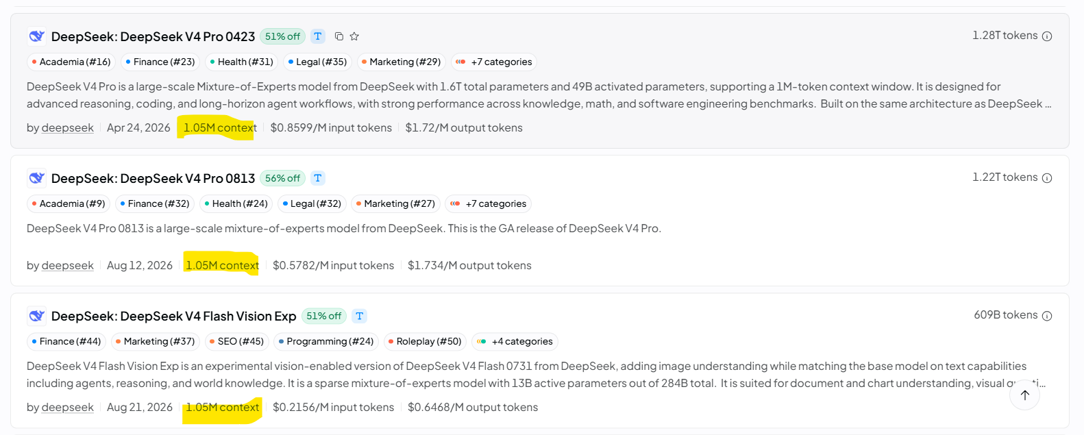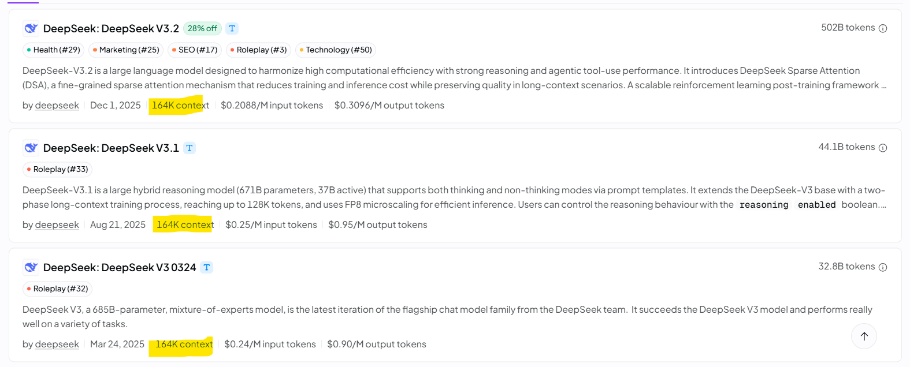

Qwen:
